World War I
Glossary

Assassination: to murder an important person by surprise attack
Armistice: an agreement to stop fighting so that peace can be discussed.
Diplomats: people who have been chosen to represent a government when it deals with other governments.

What Was World War I?
World War I was an extremely bloody war that engulfed Europe from 1914 to 1919, with huge losses of life and little ground lost or won. Fought mostly by soldiers in trenches, World War I saw an estimated 10 million military deaths and another 20 million wounded. While many hoped that World War I would be "the war to end all wars," the peace treaty that ended it set the stage for World War II.
Dates: 1914-1919
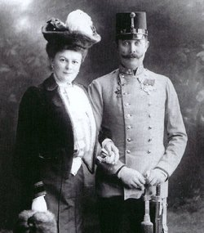

Also Known As: The Great War, WWI, The First World War

The Start of World War I
The spark that started World War I was the assassination of Austria's Archduke Francis Ferdinand and his wife Sophie. The assassination occurred on June 28, 1914 while Ferdinand was visiting the city of Sarajevo in the Austro-Hungarian province of Bosnia-Herzegovina.

A War of Attrition
From 1914 to 1917, soldiers on each side of the line fought from their trenches. They fired artillery onto the enemy's position and lobbed grenades. However, each time military leaders ordered a full-fledged attack, the soldiers were forced to leave the "safety" of their trenches.
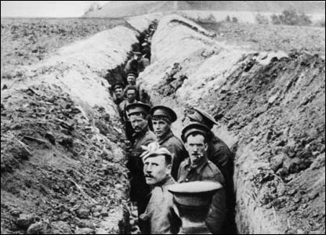
The only way to overtake the other side's trench was for the soldiers to cross "No Man's Land," the area between the trenches, on foot. Out in the open, thousands of soldiers raced across this barren land in the hopes of reaching the other side. Often, most were hewn down by machine-gun fire and artillery before they even got close.
Because of the nature of trench warfare, millions of young men were slaughtered in the battles of World War I. The war quickly became one of attrition, which meant that with so many soldiers being killed daily, eventually the side with the most men would win the war. By 1917, the Allies were starting to run low on young men.

Soldiers in the trenches during WWI

U.S. Enters the War and Russia Gets Out
The Allies needed help and they were hoping that the United States, with its vast resources of men and materials, would join on their side. However, for years, the U.S didn't want to be involved in a war that seemed so far away and that didn't seem to affect them in any great way. However several events caused the United States to take an interest in the war and on April 6, 1917, the United States officially declared war on Germany.
As the United States was entering World War I, Russia was getting ready to get out. Russia was too busy with a revolution going on within its own country and so it signed a peace treaty with Germany on March 3, 1918 and got out of the war. With the war in the east ended, Germany was able to divert those troops to the west in order to face the new American soldiers.

Armistice and the Versailles Treaty
The fighting in the west continued for another year. Millions more soldiers died, while little land was gained. However, the freshness of the American troops made a huge difference. While the European troops were tired from years of war, the Americans remained enthusiastic. Soon the Germans were retreating and the Allies were advancing. The end of the war was near.
At the end of 1918, an armistice was finally agreed upon. The fighting was to end on the 11th hour of 11th day of 11th month (11 am on Nov. 11, 1918). For the next several months, diplomats argued and compromised together in order to come up with the Versailles Treaty. The Versailles Treaty was the peace treaty that ended World War I; however, a number of its terms were so controversial that it also set the stage for World War II.
The carnage left behind by the end of World War I was staggering. By the end of the war, an estimated 10 million soldiers were killed. That averages to about 6,500 deaths a day, every day. Plus, millions of civilians were also killed. World War I is especially remembered for its slaughter for it was one of the bloodiest wars in history.

